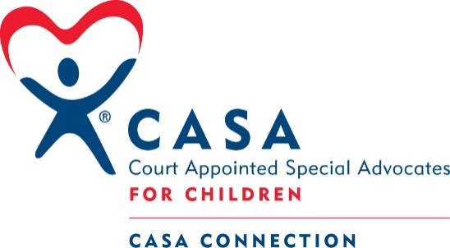
2019 Columbus Days
“I’m a Little Cutie”
Baby Contest
Saturday, August 17, 2019
Frankfort Square, Columbus NE

All age groups will be co-ed ~ prizes will be awarded for 1st, 2nd, & 3rd place in each age group ~ Judging will begin at 8:30 a.m. with the youngest contestants and the age groups will run consecutively so arrive early ~ The contest will be completed by 10:00 a.m. ~ Contest winners will be announced immediately after each age group scores are tallied.

AGE GROUPS: 0-6 MONTHS * 7-12 MONTHS * 13-18 MONTHS

Early registration fee (before or on Aug. 12th) - $15
Late registration fee (after Aug. 12th) - $20
ALL REGISTRATION FORMS & FEES MUST BE TO THE CASA OFFICE
Register and pay online
at:
Casaconnectionne.com

BY 5 P.M. ON AUGUST 15th NO EXCEPTIONS

Mail entry form & registration fee to:
CASA Connection; 2610 14th Street; Columbus NE 68601
Or hand deliver to:
1465 27th Ave. (across the alley to the north of the Sheriff’s office)
Please complete form below and return with appropriate fee:

Please direct questions to: 402-563-4944 or casacon@yahoo.com
**By participating in the baby contest, parents authorize CASA Connection to take images of themselves and their children during the event and to share these images through various media only for the purpose of publicizing CASA Connection and the baby contest. ** Proceeds from this contest will benefit CASA Connection, a program that advocates for abused and neglected children in Platte and Colfax Counties. CASA Connection is proud to be a Columbus Area United Way Partner Agency. CASA Connection would like to thank Walmart for its continued support of the baby contest.
----------------------------------------------------------------------------------------------------------------------------------------------------------------

Baby’s Name: __________________________________________________________ Gender: _____male ___ female
(Please list baby’s name as you want it announced at the event)
Mother (first, last name) _______________________________________

Father (first, last name) _______________________________________

Best number to contact: _______________________________________

Baby’s Birthdate: ______________________ Baby’s age as of 8/17/2019 (in months) _____________________

